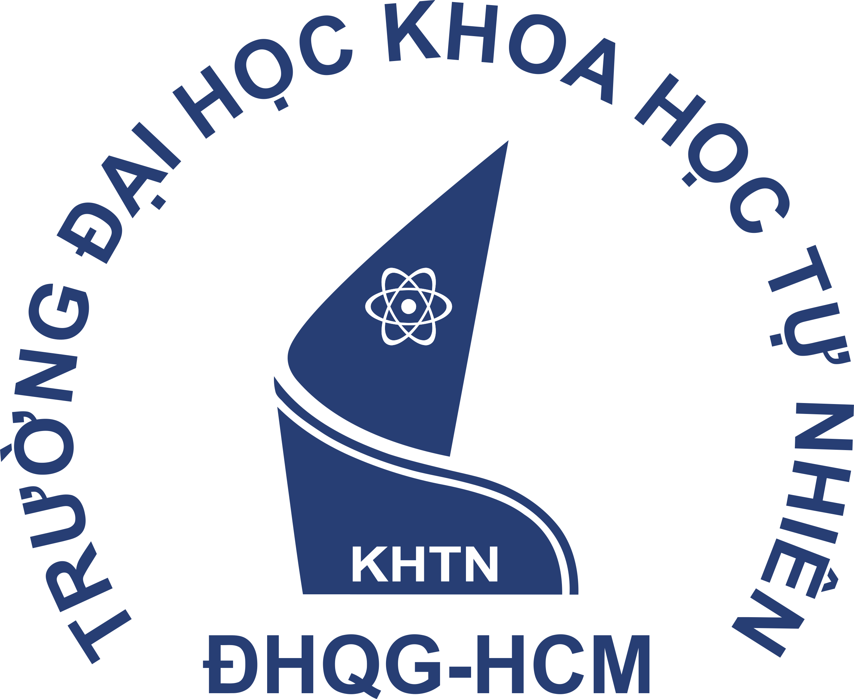

**PROJECT REPORT**

**Project 1: Windows file manager**

**Presented by:**

22127213 - Vo Minh Khoi

22127129 - Nguyen Tan Hoang  
22127042 - Le Nguyen Minh Chau  
22127158 - Nham Duc Huy

22127273 - Phan Hai Minh

**Instructors:**

Mr. Le Viet Long

Mrs. Chung Thuy Linh

Ho Chi Minh City, 14th March 2023

**Course: Operating System**